**Lambda Complex PTS (V1)**

**Introduction:**

In the dynamic landscape of project management, the need for robust, efficient, and adaptable project tracking systems has become increasingly pronounced. Within this context, our project introduces a comprehensive solution aimed at addressing the multifaceted challenges encountered in project management across various industries.

The project tracking system we propose, tentatively named "Lambda Complex," emerges as a response to the evolving demands of contemporary project management practices. With its versatile features and user-friendly interface, Lambda Complex is poised to revolutionize how teams plan, execute, and monitor their projects, thereby enhancing productivity, fostering collaboration, and driving project success.

**Purpose of Lambda Complex:**

Against this backdrop, the primary objective of Lambda Complex is to empower project teams with a comprehensive yet intuitive platform that addresses the aforementioned challenges and facilitates the seamless management of projects from initiation to completion. By leveraging cutting-edge technologies and best practices in project management, Lambda Complex aims to achieve the following:

1. **Simplify Project Management:** Lambda Complex will provide a centralized platform where project managers can plan, organize, and track all aspects of their projects efficiently. From creating project plans and defining tasks to monitoring progress and analyzing performance, Lambda Complex will streamline project management workflows, saving time and effort for project teams.
2. **Enhance Collaboration:** Recognizing the importance of collaboration in project success, Lambda Complex will offer robust communication and collaboration features. Team members will be able to share updates, exchange feedback, and collaborate on tasks in real-time, fostering a culture of teamwork and transparency.
3. **Optimize Resource Utilization:** With Lambda Complex's resource management capabilities, project managers will have visibility into resource availability, skills, and workload. This will enable them to allocate resources effectively, balance workloads, and prevent resource bottlenecks, ensuring optimal resource utilization throughout the project lifecycle.
4. **Provide Actionable Insights:** Lambda Complex will leverage data analytics and reporting tools to provide stakeholders with actionable insights into project performance, risks, and trends. By visualizing key metrics and KPIs, Lambda Complex will empower project managers to make data-driven decisions, identify areas for improvement, and proactively address project challenges.

## How can Lambda Complex help you to track projects effectively?

Lambda Complex is designed to make project management as simple as possible. We know projects are complicated things, so we made tools to make it as easy as possible. In addition, project management still has not offered a great solution for small teams. You are wearing many hats and everyone is firing in on tasks, projects and details. You help with everything, as well as having to do the day job. Research has shown that smaller teams, even within larger organizations, make decisions that more quickly affect their customers…but it seems like project management platforms have been slow to embrace that shift.  
  
project tracking system sounds comprehensive and well-structured, addressing key aspects of project management such as calendar event management, milestone tracking, and task assignment. Here's a breakdown of the functionalities you've described:

**Calendar Event Management:** Calendar event management provides users with a visual representation of project timelines, deadlines, meetings, and other important events. This feature enables users to schedule and organize their tasks effectively, ensuring that project activities are completed on time.

**Project Tracking Hierarchy:** Your project tracking system follows a hierarchical structure consisting of Projects, Milestones, Goals, and Tasks, which allows for granular control and tracking of project progress.

1. **Projects:** Projects serve as the overarching entities within your system, representing the main initiatives or endeavors undertaken by the organization. Each project may have multiple milestones associated with it.
2. **Milestones:** Milestones mark significant stages or achievements within a project. Admins are responsible for managing projects and assigning teams to specific milestones. Milestones act as key checkpoints, helping teams track progress and stay aligned with project objectives.
3. **Goals:** Goals represent specific objectives or deliverables that need to be accomplished within a milestone. Leads manage goals and tasks associated with them, ensuring that project milestones are met according to schedule.
4. **Tasks:** Tasks are the individual action items required to complete goals and ultimately achieve project milestones. Developers are responsible for executing tasks assigned to them by leads. This granular level of task management facilitates collaboration, accountability, and progress tracking.

**User Roles and Permissions:** Your system defines different user roles, namely Admin, Lead, and Developer, each with specific responsibilities and permissions:

1. **Admin:** Admins have overarching authority and responsibility for managing projects, assigning teams, and approving/rejecting changes to milestones. They ensure that project objectives are aligned with organizational goals and oversee the project management process.
2. **Lead:** Leads oversee goal and task management within milestones. They are responsible for assigning tasks to developers, monitoring progress, and ensuring that goals are met on time. Leads also have the authority to accept or reject changes proposed by developers.
3. **Developer:** Developers are tasked with executing specific tasks assigned to them by leads. They collaborate with other team members, provide updates on task progress, and seek approval from leads for any changes or updates to tasks.

**Approval Workflow:** Your system incorporates an approval workflow to ensure accountability and control over changes made to milestones and tasks. Admins and leads have the authority to approve or reject changes proposed by team members, ensuring that project plans are followed and deviations are appropriately managed.

Overall, Lambda Complex tracking system provides a structured framework for managing projects, facilitating collaboration, and ensuring that project objectives are met efficiently. By incorporating user roles, hierarchical project tracking, and an approval workflow, your system enables teams to work together effectively, track progress accurately, and delivers successful outcomes.

Adding change tracking functionality similar to Git for projects, milestones, tasks, and goals is a significant enhancement to Lambda Complex tracking system. This feature not only enhances transparency but also facilitates accountability, version control, and historical analysis of project modifications. Here's how this addition can be implemented:

**Change Tracking Functionality:**

1. **Version Control:** Implement a version control system for projects, milestones, goals, and tasks. Each time a change is made, the system creates a new version, capturing the state of the project at that point in time. This ensures that historical data is preserved, and users can revert to previous versions if needed.
2. **Change History:** Maintain a detailed log of all changes made to projects, milestones, goals, and tasks. Include information such as the user who made the change, the timestamp of the modification, and a description of the change. This provides users with visibility into the evolution of the project and helps track who made which changes.
3. **Timeline Chart:** Display the change history on a timeline chart, similar to Git's commit history. Users can visualize the sequence of changes, their frequency, and their impact on project progress. The timeline chart can include filters to view changes by user, date range, or specific project components (e.g., milestones, goals).
4. **Notifications:** Notify relevant stakeholders whenever a change is made to a project, milestone, goal, or task. This ensures that team members stay informed about updates and can review changes promptly. Notifications can be delivered via email, in-app notifications, or integrations with messaging platforms like Slack.

**Benefits:**

* **Transparency:** Users can track all changes made to projects, milestones, goals, and tasks, promoting transparency and accountability within the project team.
* **Auditing:** The change history serves as an audit trail, allowing administrators to monitor user activity and identify any unauthorized changes or discrepancies.
* **Decision Making:** By visualizing changes on a timeline chart, project managers can assess the impact of modifications and make informed decisions about project direction and resource allocation.
* **Collaboration:** The diff view enables collaborative review and discussion of changes, fostering communication and alignment among team members.
* **Continuous Improvement:** Analyzing historical data and trends in the change history can help identify areas for process improvement and optimization in project management practices.

By incorporating Git-like change tracking functionality into Lambda Complex tracking system, you enhance its capabilities for version control, transparency, and collaboration, ultimately enabling more effective project management and delivery.

Incorporating the ability to revert projects, milestones, goals, and tasks to previous versions and allowing them to be marked as completed or abandoned adds significant flexibility and control to Lambda Complex tracking system. Additionally, the capability to revive completed or abandoned components for maintenance ensures that historical data remains accessible and actionable. Here's how these functionalities can be implemented:

**Reverting to Previous Versions:**

1. **Revert Functionality:** Enable users to revert projects, milestones, goals, and tasks to a previous version or the initial version. This allows teams to undo changes or reset components to a stable state if necessary.
2. **Version Management:** Maintain a version history for each project, milestone, goal, and task, capturing all modifications and enabling users to navigate through different versions. Users can select a specific version to revert to, ensuring accuracy and reliability in project management.
3. **Confirmation Prompt:** Implement a confirmation prompt when reverting components to a previous version to prevent accidental data loss. Users should confirm their decision before the revert action is executed.

**Completion and Abandonment:**

1. **Completion Status:** Allow users to mark projects, milestones, goals, and tasks as completed when they have been successfully finished. Completed components should be clearly distinguished from active ones to signify their status.
2. **Abandonment Status:** Similarly, provide the option to mark components as abandoned if they are no longer relevant or feasible. Abandoned components should be archived but remain accessible for reference.

**Revival for Maintenance:**

1. **Revival Functionality:** Enable users to revive completed or abandoned projects, milestones, goals, and tasks for maintenance or reevaluation. This allows teams to revisit past work, make updates, or extract valuable insights for future projects.
2. **Archive Management:** Maintain an archive of completed and abandoned components, ensuring that they can be easily retrieved when needed. Users should have the ability to search and filter archived items based on criteria such as date, status, or project ID.
3. **Update Notifications:** Notify relevant stakeholders when a completed or abandoned component is revived for maintenance. This ensures that team members are aware of any changes or updates being made to historical data.

**Benefits:**

* **Flexibility:** Users can revert components to previous versions, mark them as completed or abandoned, and revive them for maintenance as needed, providing flexibility in project management.
* **Risk Mitigation:** The ability to revert to stable versions helps mitigate risks associated with project changes or errors, ensuring project integrity and continuity.
* **Historical Reference:** Completed and abandoned components serve as valuable historical data for analysis, benchmarking, and continuous improvement efforts.
* **Resource Optimization:** Reviving completed components for maintenance allows teams to leverage existing work, reducing duplication of effort and optimizing resource allocation.

By incorporating these functionalities into Lambda Complex tracking system, you empower users to manage projects more effectively, maintain historical data comprehensively, and adapt to changing project requirements with confidence.

Expanding Lambda Complex tracking system to include comprehensive data export, grid view enhancements, and file upload functionality significantly enhances its usability and flexibility. Here's how these features can be integrated:

**Data Export Functionality:**

1. **PDF and Excel Export:** Provide users with the ability to export data from the grid view to PDF or Excel formats. This enables users to generate customizable reports and share project information with stakeholders in their preferred format.
2. **Export Options:** Offer configurable export options, allowing users to select specific columns, filters, and sorting preferences to customize the exported data according to their requirements.

**Grid View Enhancements:**

1. **Grouping:** Enable users to group data in the grid view based on specific criteria such as project, milestone, goal, or task attributes. Grouping enhances data organization and facilitates analysis by allowing users to view data hierarchically.
2. **Sorting:** Implement sortable columns in the grid view, enabling users to sort data alphabetically, numerically, or chronologically. This allows for easy identification of trends, patterns, and outliers within the dataset.
3. **Filtering:** Provide filterable columns in the grid view, allowing users to apply dynamic filters to narrow down the displayed data based on specific criteria. Filters enhance data visibility and enable users to focus on relevant information.

**File Upload Functionality:**

1. **Versioned File Upload:** Allow users to upload files (e.g., documents, images, spreadsheets) for projects, milestones, goals, and tasks at each version. Files are associated with specific versions, ensuring that the project's documentation remains organized and accessible.
2. **File Management:** Implement file management capabilities, including the ability to view, download, update, and delete uploaded files. Users can maintain a repository of project-related documents and assets, facilitating collaboration and knowledge sharing.
3. **File Versioning:** Track changes made to uploaded files over time, similar to version control for project components. Users can access previous versions of files, view revision history, and revert to earlier versions if needed.

**Benefits:**

* **Enhanced Reporting:** PDF and Excel export functionality enables users to create professional reports and share project data with stakeholders efficiently.
* **Improved Data Analysis:** Grid view enhancements such as grouping, sorting, and filtering empower users to analyze project data more effectively, leading to better decision-making and problem-solving.
* **Centralized Documentation:** File upload functionality allows users to centralize project documentation and assets, ensuring that all relevant information is easily accessible and up-to-date.
* **Collaborative Workflows:** Versioned file upload facilitates collaboration by providing a centralized platform for sharing and managing project-related files across teams and stakeholders.

By incorporating these features into Lambda Complex tracking system, you provide users with powerful tools for data management, analysis, and collaboration, ultimately enhancing the efficiency and effectiveness of project management processes.

Integrating a comprehensive work timeline feature that records all user activities, from team creation to changes in project components, and displaying these activities in a calendar view adds valuable insights into project management workflows. Here's how this feature can be implemented:

**Work Timeline Functionality:**

1. **Activity Logging:** Capture all user activities, including team creation, project modifications, milestone updates, goal adjustments, task assignments, file uploads, and any other relevant actions. Each activity is recorded with details such as the user responsible, timestamp, and nature of the action taken.
2. **Timeline Entries:** Generate timeline entries for each recorded activity, summarizing the event and providing context for users to understand the sequence of actions taken within the project management system.
3. **Customizable Filters:** Offer customizable filters to allow users to view specific types of activities, such as changes to milestones or task assignments, making it easier to track relevant updates within the timeline.

**Calendar View Integration:**

1. **Daily Activity Display:** Display the recorded activities in a calendar view, allowing users to visualize their daily workflow and track the progression of tasks, milestones, and goals over time.
2. **Color-Coding:** Color-code calendar entries based on activity type or user role to provide visual cues and make it easier for users to identify different types of activities at a glance.
3. **Navigation Controls:** Include navigation controls that allow users to switch between daily, weekly, or monthly views of the calendar, enabling them to zoom in or out as needed to focus on specific time periods.

**Benefits:**

* **Comprehensive Activity Tracking:** The work timeline records all user activities within the project management system, providing a comprehensive audit trail of changes and updates.
* **Enhanced Transparency:** Users gain visibility into the actions taken by team members, fostering transparency and accountability within the project team.
* **Improved Communication:** Calendar view integration allows users to visualize their daily activities and plan their workflow more effectively, facilitating communication and coordination among team members.
* **Efficient Monitoring:** By tracking changes to projects, milestones, goals, and tasks in real-time, project managers can monitor progress, identify bottlenecks, and take proactive measures to ensure project success.
* **Historical Analysis:** The recorded timeline entries serve as valuable historical data for analysis and retrospective reviews, enabling teams to identify trends, patterns, and areas for improvement in project management practices.

By incorporating a comprehensive work timeline feature and integrating it with a calendar view, Lambda Complex tracking system provides users with a powerful tool for tracking activities, monitoring progress, and fostering collaboration across project teams.

**Technologies Used:**

* **Python Flask (Back end)**
* **SQL Server (Database)**
* **Html, CSS, JS, JQuery, Ajax (Front end)**
* **Kendo UI Library and Other JQuery plug-ins**

**Table Structures:**

* **Calendar Transaction table:**

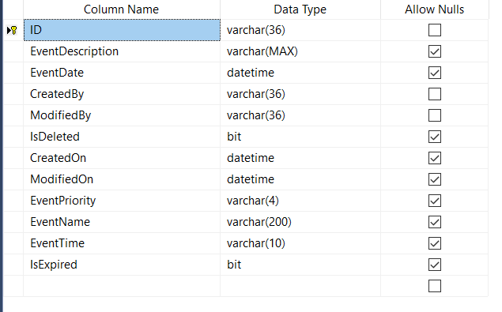

* **File Transaction table**

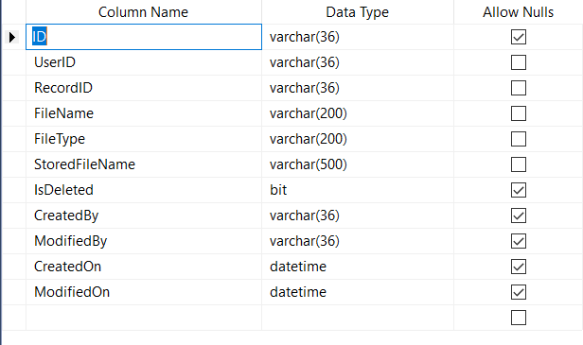

* **Goal Master Table**

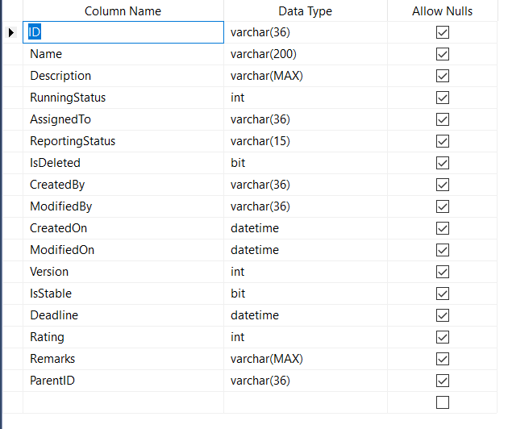

* **Goal Changes Transaction Table**
* 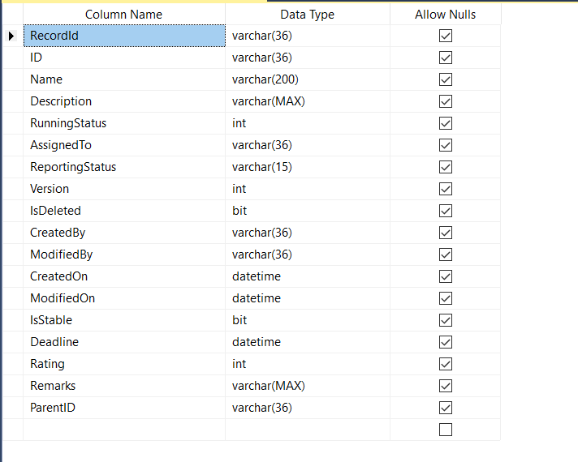**Milestone Master Table**

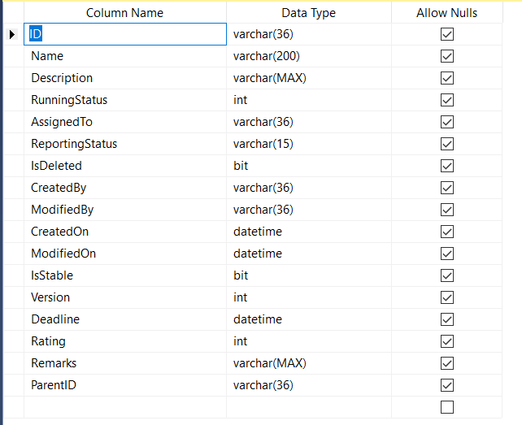

* **Milestone Change Transaction Table**

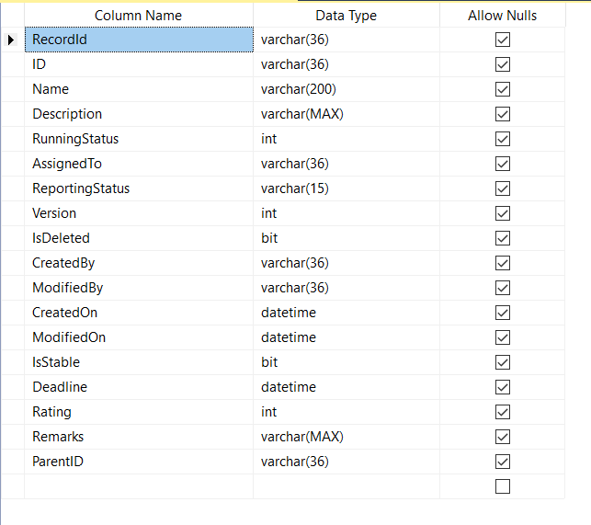

* **Project Master Transaction Table**

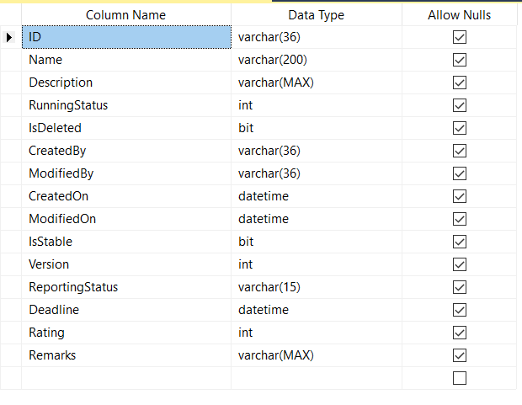

* **Project Change Transaction Table**

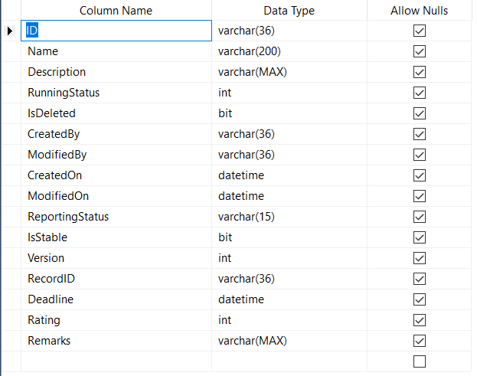

* **Task Master Table**

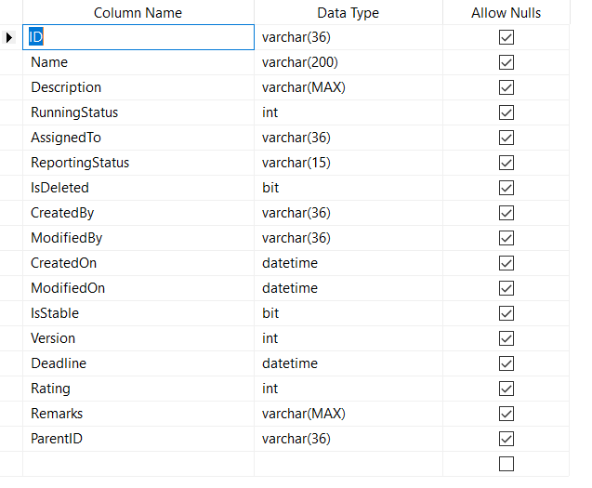

* **Task Change Transaction Table**

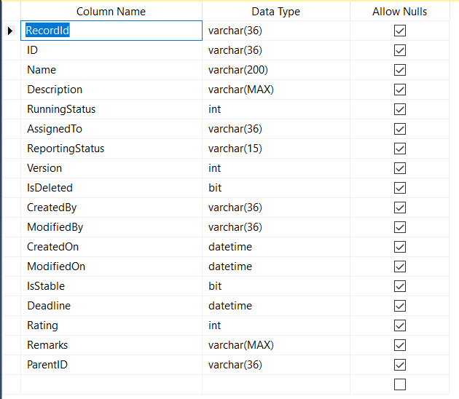

* **Team Master Table**

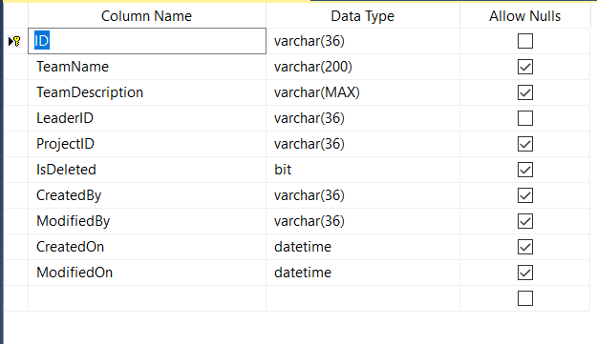

* **Team Member Transaction Table**

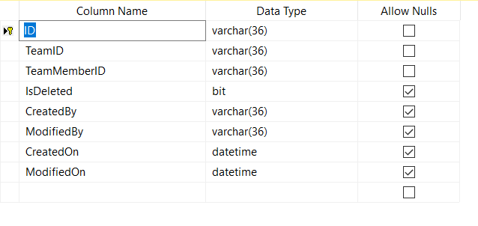

* **User Master Table**

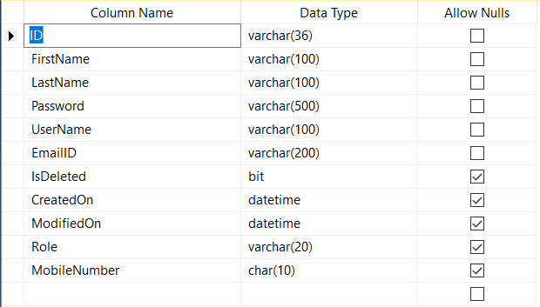

* **Work timeline Transaction Table**

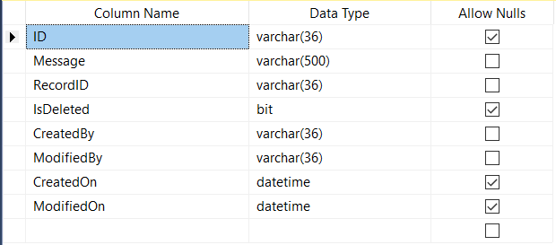

**Lambda Complex Demos:-**

* 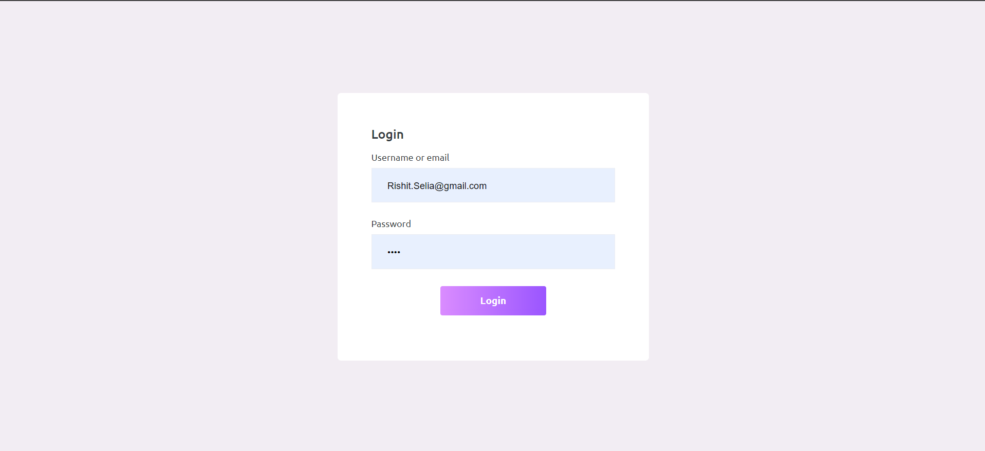**Login Demo**
* 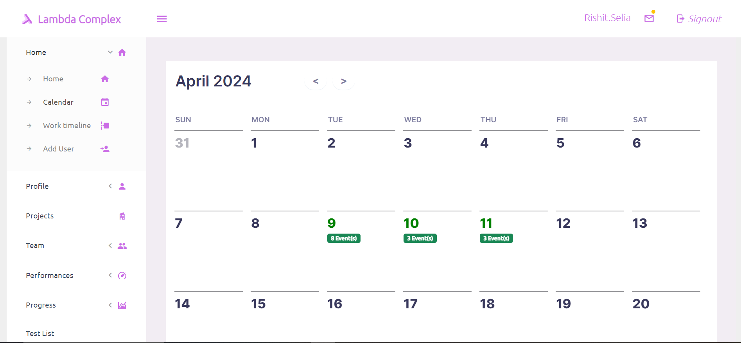**Calendar events calendar view Demo**
* **Calendar events list view Demo**

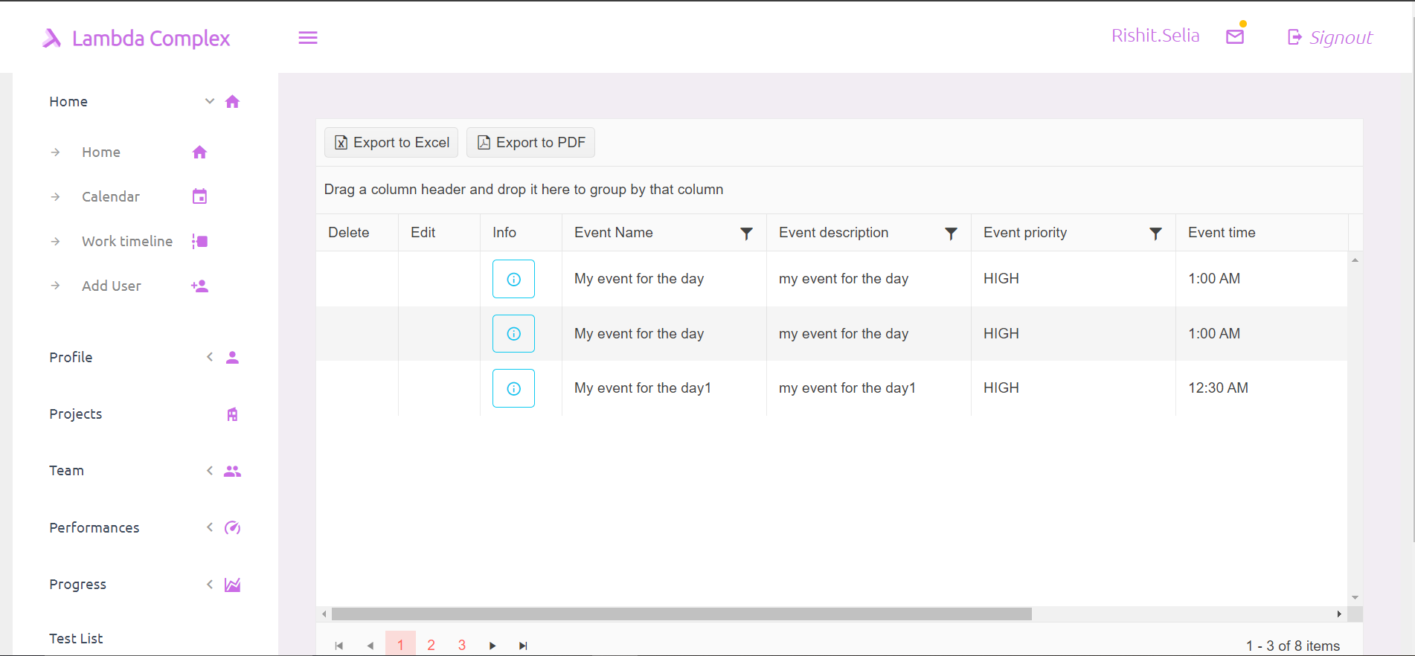

* **Calendar events time line view Demo**

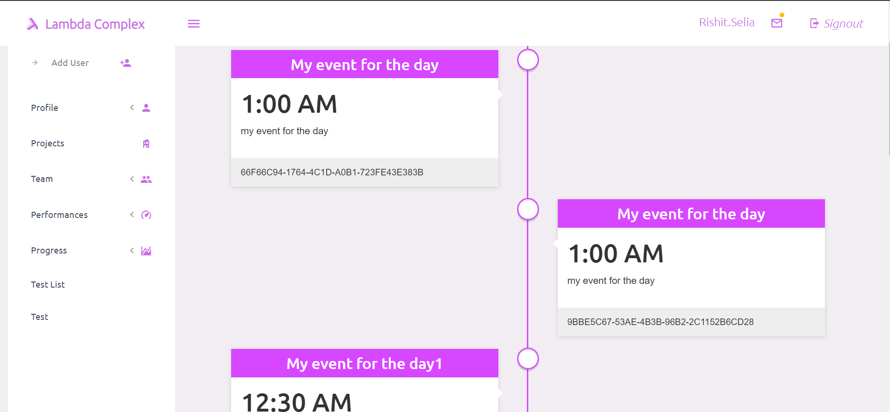

* **Team list view Demo**

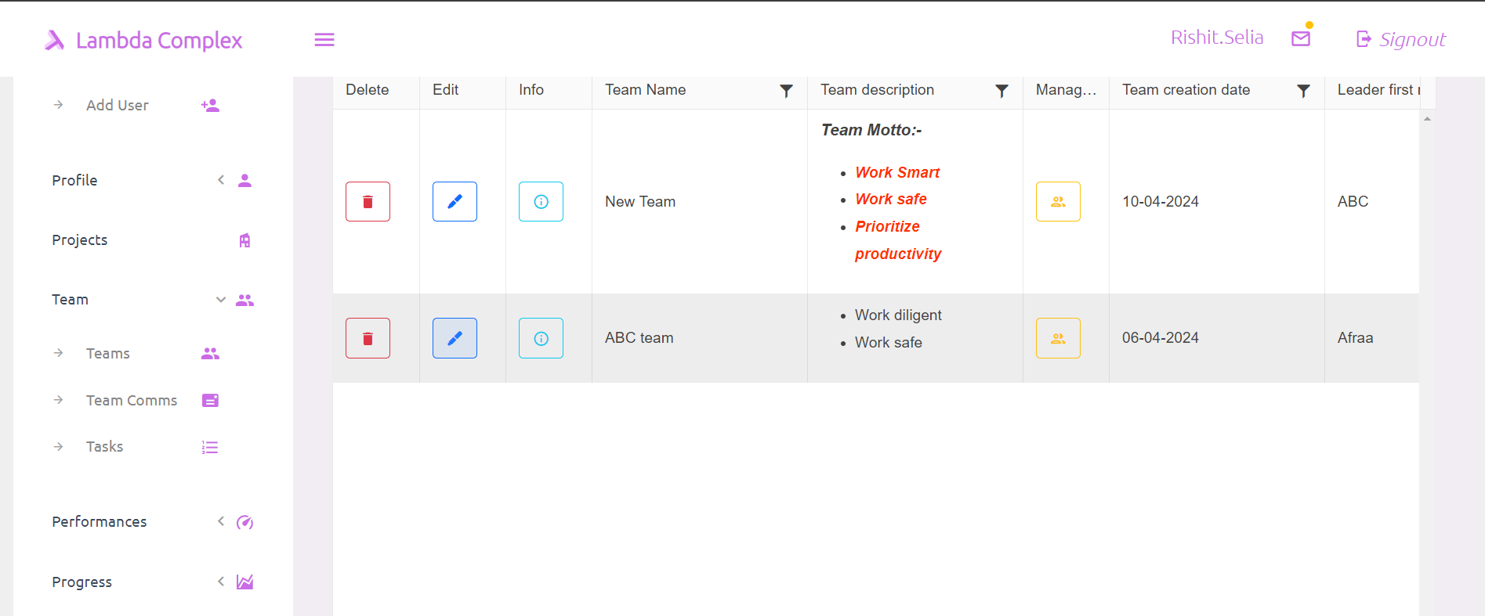

**Future enhancements:**

Aiming to add new feature and take the project from project tracking system to a grand scale and making it a institute or organization management system by incorporating Real time communications and performance monitoring in the system while the system also tracks the resource allocations of the organization and able to give real time updates and also solve minor issues with the existing software.

**Conclusion:**

In conclusion, the project tracking system represents a significant milestone in the organization's journey towards improved project management practices. By leveraging cutting-edge technologies and best practices in project management, the system has empowered teams to collaborate more effectively, make data-driven decisions, and deliver projects successfully. Moving forward, continued investment in the system's development, adoption, and integration will be essential to realizing its full potential and driving sustained organizational growth and success.

The development and implementation of the project tracking system mark a pivotal moment in our organization's quest for excellence in project management. This comprehensive system, equipped with a plethora of features ranging from calendar event management to Git-like change tracking, has not only revolutionized how projects are planned, executed, and monitored but has also catalyzed a paradigm shift in our approach to project management.

Through meticulous planning, collaborative efforts, and unwavering commitment to innovation, we have successfully delivered a solution that meets the diverse needs of our project teams and stakeholders. The project tracking system has empowered teams to streamline workflows, enhance collaboration, and make informed decisions based on real-time data and insights.

The tangible results achieved through the adoption of the project tracking system are evident in improved project visibility, enhanced collaboration among team members, and increased efficiency in project execution. By providing stakeholders with the tools they need to track progress, mitigate risks, and drive continuous improvement, the system has become an indispensable asset in our organizational toolkit.

As we reflect on the journey thus far, it is clear that the project tracking system represents more than just a technological achievement—it embodies our organization's commitment to excellence, innovation, and continuous improvement. However, our journey does not end here. Moving forward, we remain dedicated to the ongoing development, optimization, and integration of the system to meet the evolving needs of our organization and stakeholders.

In conclusion, the project tracking system stands as a testament to our collective vision, determination, and ingenuity. It is a testament to what we can achieve when we harness the power of technology, collaboration, and relentless pursuit of excellence. With the project tracking system as our foundation, we are poised to chart new heights of success, drive transformative change, and deliver value to our organization and stakeholders for years to come.

**Thank you.......**